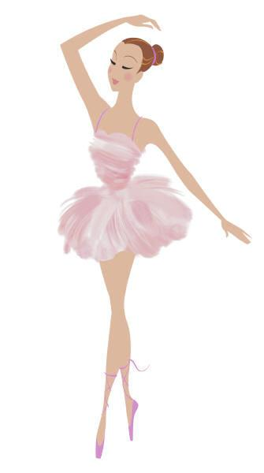
You Are Cordially Invited to the
Book Ball
Please Join Annika Cushnyr in the launch of her Gold Award project, Start My Library. There will be many activities, including Waltz lessons, hair braiding, and information about the Gold, Silver, and Bronze Awards.
Cost: $2 per person, girls of all ages
All Girls will receive a patch.
When: April 13th 2013, 2pm-4pm
Where: Paradise Hills United Methodist Church
4700 Paradise Blvd NW
Albuquerque, NM 87114
Dress: As Fancy or as Casual as you wish!
The Book Challenge! The troop that brings in the most new or gently used books to be donated to the library will receive a gift card to Dairy Queen!!
Please RSVP to StartMyLibrary@gmail.com by March 25th with the leader’s name, number of girls attending, and an address where the patches can be mailed to. Money will be collected upon arrival along with completed permission slips for all girls attending. For more information about the project please visit, www.startmylibrary.weebly.com

